24. Write a C program for RSA system, the public key of a given user is e = 31, n = 3599. What is the private key of this user? Hint: First use trial-and-error to determine p and q; then use the extended Euclidean algorithm to find the multiplicative inverse of 31 modulo f(n).
#include <stdio.h>
int gcdExtended(int a, int b, int *x, int *y) {
if (a == 0) {
*x = 0;
*y = 1;
return b;
}
int x1, y1;
int gcd = gcdExtended(b % a, a, &x1, &y1);
*x = y1 - (b / a) * x1;
*y = x1;
return gcd;
}
int modInverse(int e, int phi) {
int x, y;
gcdExtended(e, phi, &x, &y);
return (x % phi + phi) % phi;
}

int main() {
int e = 31;
int p = 59, q = 61;
int phi = (p - 1) * (q - 1);
int d = modInverse(e, phi);

printf("Private Key d = %d\n", d);
return 0;
}
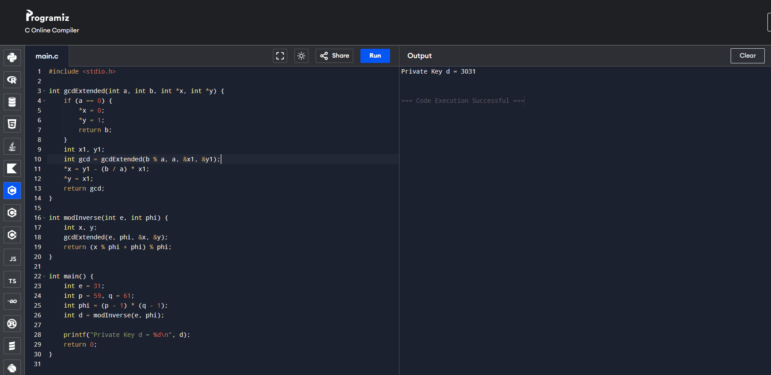
25. Write a C program for set of blocks encoded with the RSA algorithm and we don’t have the private key. Assume n = pq, e is the public key. Suppose also someone tells us they know one of the plaintext blocks has a common factor with n. Does this help us in any way?
#include <stdio.h>
int gcd(int a, int b) {
while (b != 0) {
int t = b;
b = a % b;
a = t;
}
return a;
}

int main() {
int n = 3599; // n = p * q
int m = 118; // plaintext block sharing factor with n

int factor = gcd(m, n);

if (factor > 1 && factor < n) {
printf("Common factor found: %d\n", factor);
printf("Other factor: %d\n", n / factor);
printf("RSA is broken.\n");
} else {
printf("No useful information gained.\n");
}

return 0;
}
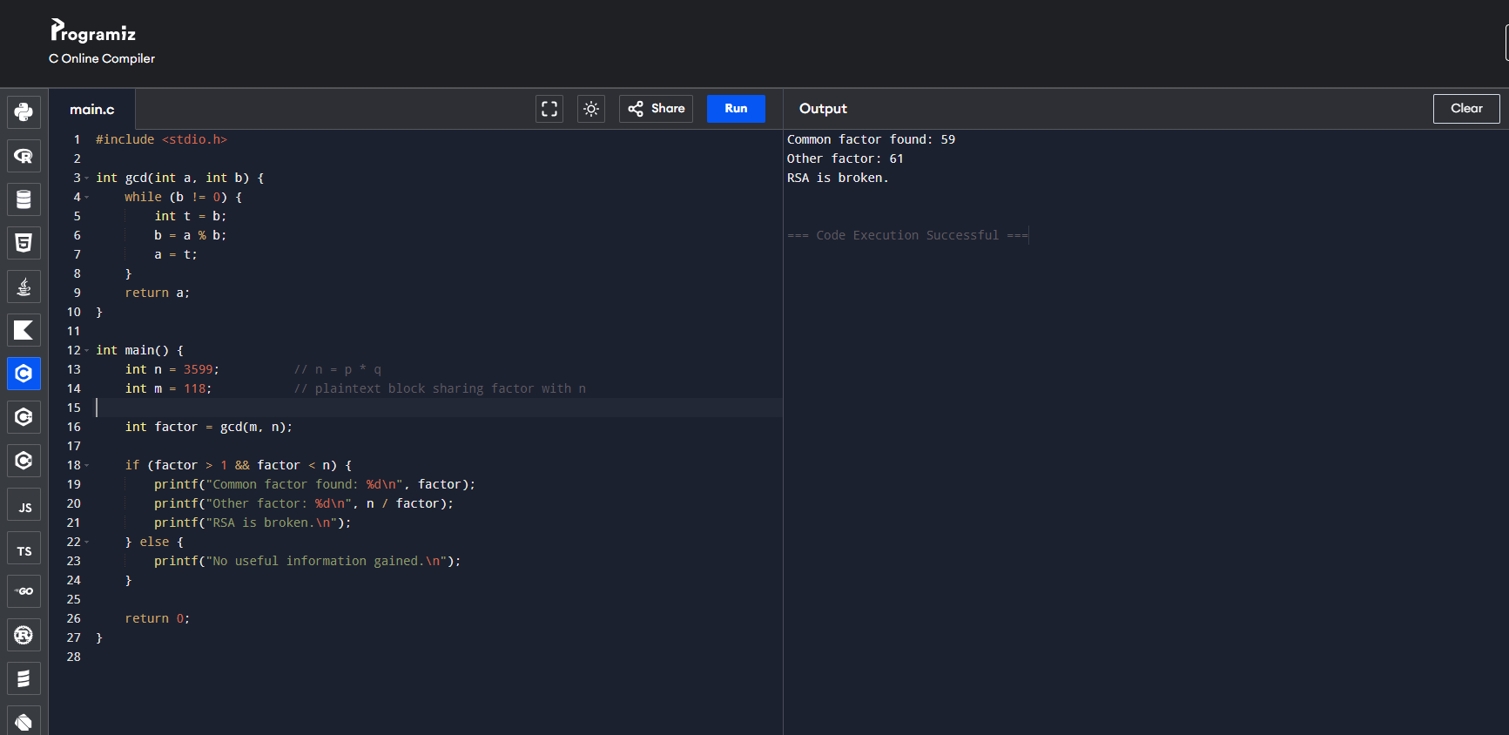

26. Write a C program for RSA public-key encryption scheme, each user has a public key, e, and a private key, d. Suppose Bob leaks his private key. Rather than generating a new modulus, he decides to generate a new public and a new private key. Is this safe?
#include <stdio.h>

int main() {
int n = 3599;
int d = 3031;

printf("Private key leaked: d = %d\n", d);
printf("Modulus n = %d\n", n);
printf("Keeping the same n is NOT secure.\n");
printf("Attacker can factor n and break all future keys.\n");

return 0;
}
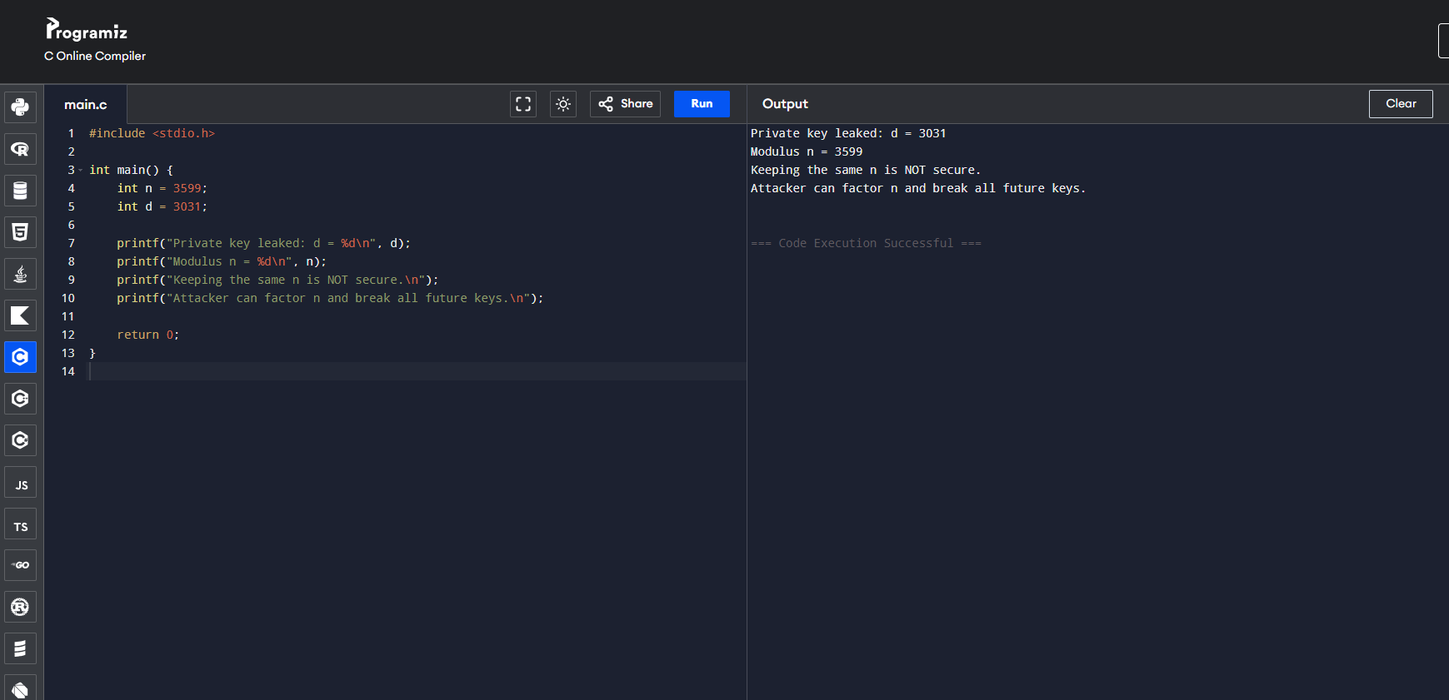

27. Write a C program for Bob uses the RSA cryptosystem with a very large modulus n for which the factorization cannot be found in a reasonable amount of time. Suppose Alice sends a message to Bob by representing each alphabetic character as an integer between 0 and 25 (A S 0, c, Z S 25) and then encrypting each number separately using RSA with large e and large n. Is this method secure? If not, describe the most efficient attack against this encryption method.
#include <stdio.h>

long long modExp(long long base, long long exp, long long mod) {
long long result = 1;
while (exp > 0) {
if (exp % 2 == 1)
result = (result * base) % mod;
base = (base * base) % mod;
exp /= 2;
}
return result;
}

int main() {
long long e = 31;
long long n = 3599;
long long ciphertext = 1808; // intercepted block

for (int m = 0; m < 26; m++) {
if (modExp(m, e, n) == ciphertext) {
printf("Recovered plaintext: %c\n", 'A' + m);
break;
}
}

return 0;
}
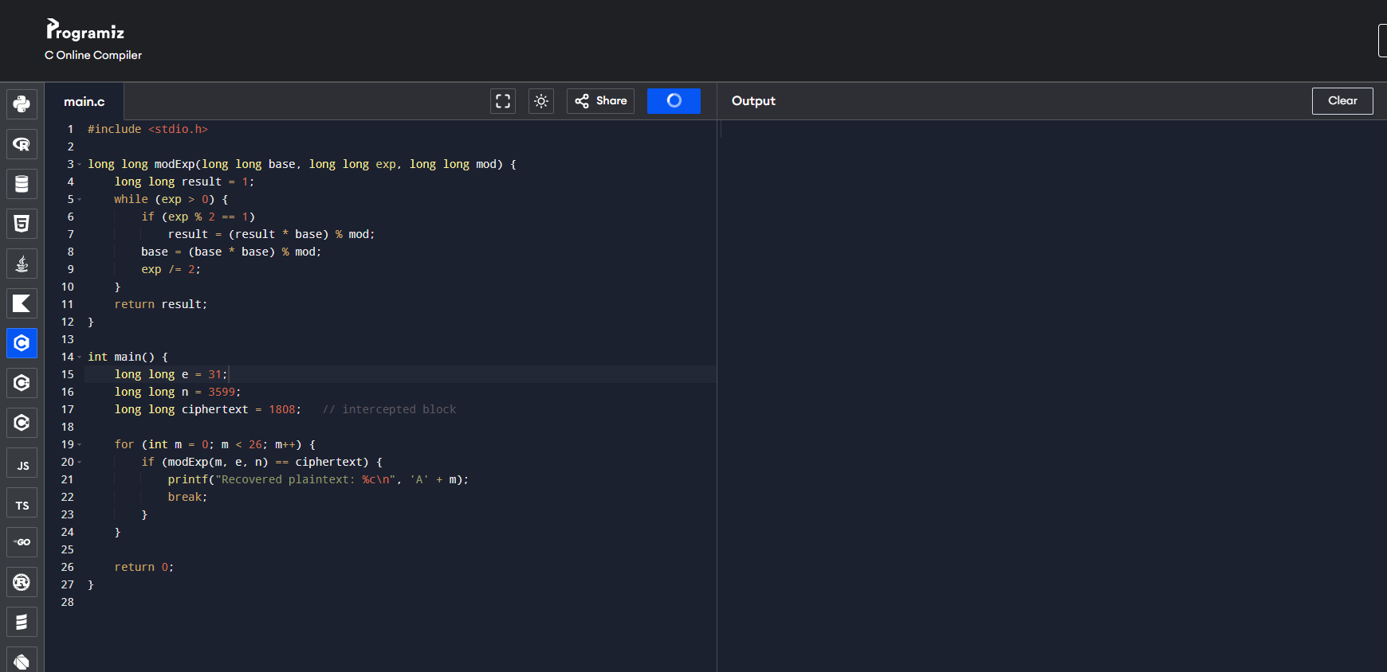
28. Write a C program for Diffie-Hellman protocol, each participant selects a secret number x and sends the other participant ax mod q for some public number a. What would happen if the participants sent each other xa for some public number a instead? Give at least one method Alice and Bob could use to agree on a key. Can Eve break your system without finding the secret numbers? Can Eve find the secret numbers?
#include <stdio.h>
long long modExp(long long base, long long exp, long long mod) {
long long result = 1;
while (exp > 0) {
if (exp % 2)
result = (result * base) % mod;
base = (base * base) % mod;
exp /= 2;
}
return result;
}

int main() {
long long a = 5, q = 23;
long long x = 6, y = 15;

long long A = modExp(a, x, q);
long long B = modExp(a, y, q);

long long keyAlice = modExp(B, x, q);
long long keyBob = modExp(A, y, q);

printf("Alice Key: %lld\n", keyAlice);
printf("Bob Key: %lld\n", keyBob);

return 0;
}
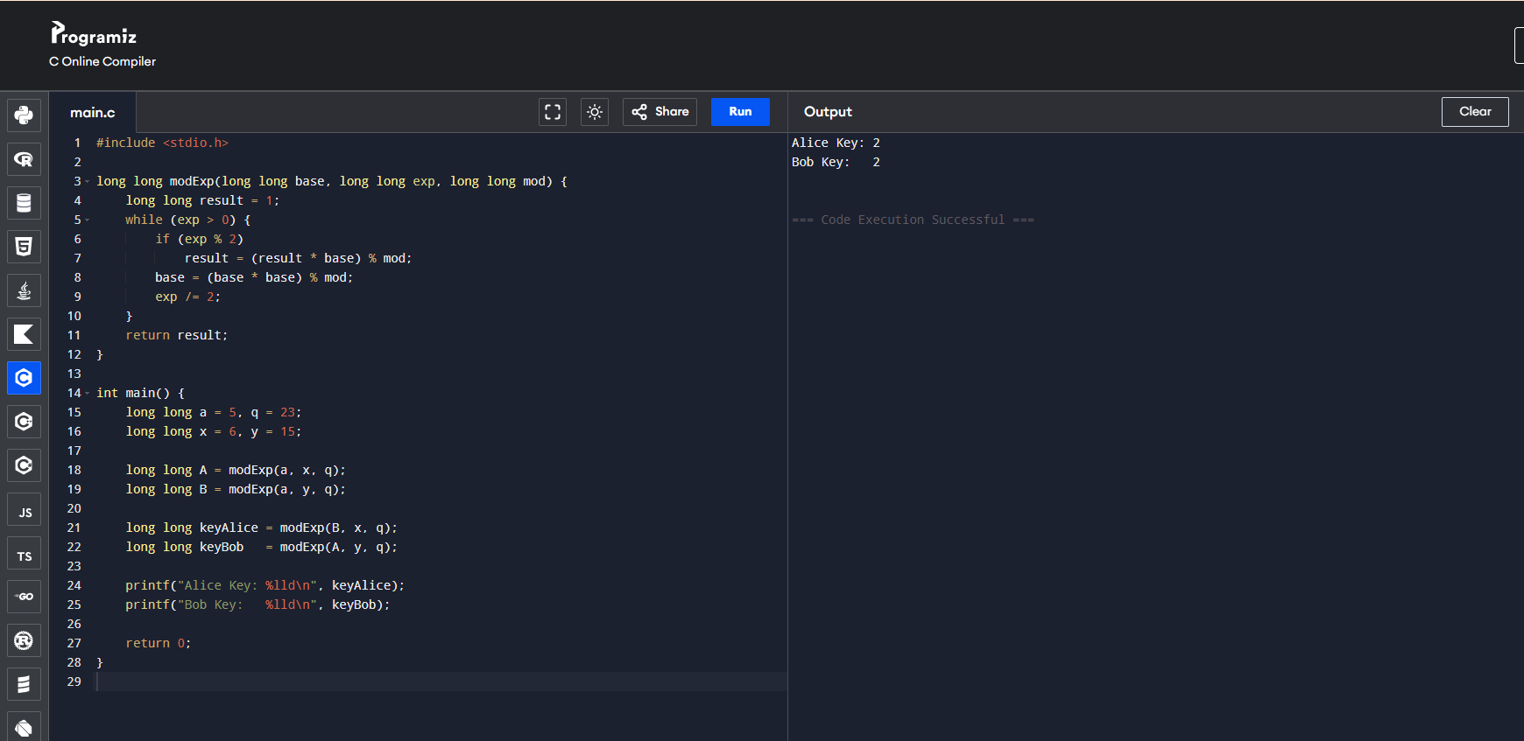

29. Write a C program for SHA-3 option with a block size of 1024 bits and assume that each of the lanes in the first message block (P0) has at least one nonzero bit. To start, all of the lanes in the internal state matrix that correspond to the capacity portion of the initial state are all zeros. Show how long it will take before all of these lanes have at least one nonzero bit. Note: Ignore the permutation. That is, keep track of the original zero lanes even after they have changed position in the matrix.
#include <stdio.h>

int main() {
int rate_lanes = 16; // 1024 / 64
int capacity_lanes = 9; // 576 / 64

int rate[16];
int capacity[9];

for (int i = 0; i < rate_lanes; i++)
rate[i] = 1; // at least one non-zero bit

for (int i = 0; i < capacity_lanes; i++)
capacity[i] = 0; // initially zero

for (int block = 1; block <= 1000; block++) {
for (int i = 0; i < rate_lanes; i++)
rate[i] ^= 1; // absorb message (example)

int allNonZero = 1;
for (int i = 0; i < capacity_lanes; i++) {
if (capacity[i] == 0) {
allNonZero = 0;
break;
}
}

if (allNonZero) {
printf("All capacity lanes non-zero after %d blocks\n", block);
return 0;
}
}

printf("Capacity lanes never become non-zero (permutation ignored)\n");
return 0;
}
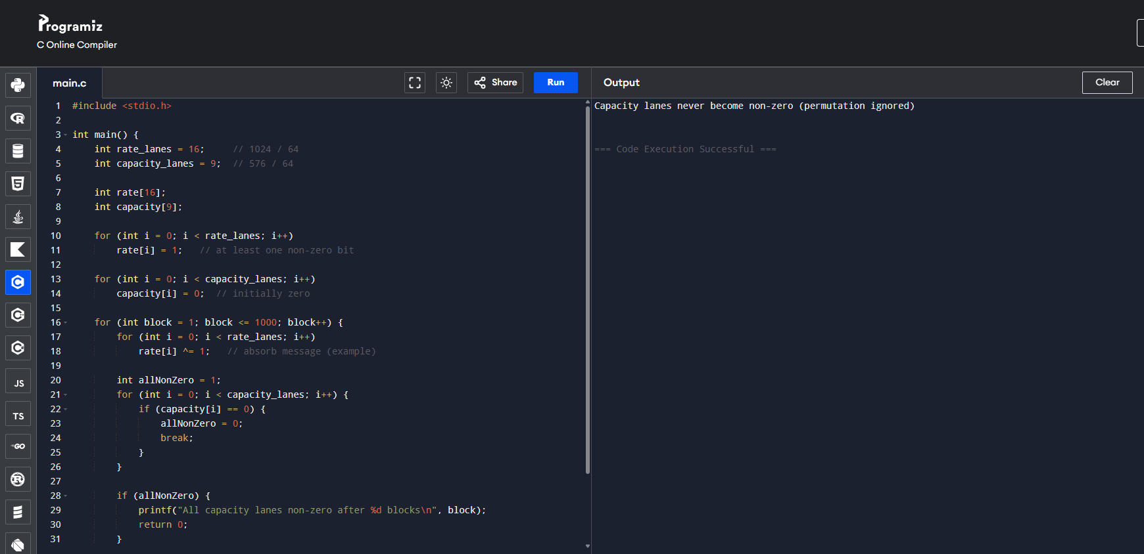
30. Write a C program for CBC MAC of a oneblock message X, say T = MAC(K, X), the adversary immediately knows the CBC MAC for the two-block message X || (X  T) since this is once again.
#include <stdio.h>

unsigned char E(unsigned char k, unsigned char x) {
return x ^ k; // simple XOR-based "cipher" for demo
}

int main() {
unsigned char K = 0x0F;
unsigned char X = 0x55;

unsigned char T = E(K, X);

unsigned char C1 = E(K, X);
unsigned char C2 = E(K, X ^ T ^ C1);

printf("MAC(K, X) = 0x%X\n", T);
printf("MAC(K, X || (X XOR T)) = 0x%X\n", C2);

return 0;
}
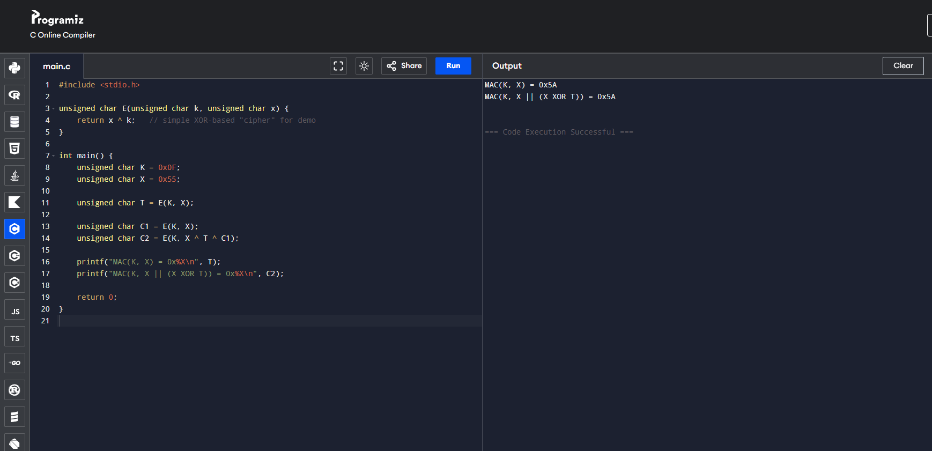

31. Write a C program for subkey generation in CMAC, it states that the block cipher is applied to the block that consists entirely of 0 bits. The first subkey is derived from the resulting string by a left shift of one bit and, conditionally, by XORing a constant that depends on the block size. The second subkey is derived in the same manner from the first subkey.
- What constants are needed for block sizes of 64 and 128 bits?
- How the left shift and XOR accomplishes the desired result.
#include <stdio.h>
#include <string.h>

#define BLOCK_SIZE 16 // 128 bits
#define Rb 0x87 // constant for 128-bit block

void leftShift(unsigned char *out, unsigned char *in) {
unsigned char carry = 0, nextCarry;
for (int i = BLOCK_SIZE - 1; i >= 0; i--) {
nextCarry = (in[i] & 0x80) ? 1 : 0;
out[i] = (in[i] << 1) | carry;
carry = nextCarry;
}
}

void generateSubkey(unsigned char *k1, unsigned char *k2, unsigned char *L) {
leftShift(k1, L);
if (L[0] & 0x80)
k1[BLOCK_SIZE - 1] ^= Rb;

leftShift(k2, k1);
if (k1[0] & 0x80)
k2[BLOCK_SIZE - 1] ^= Rb;
}

int main() {
unsigned char L[BLOCK_SIZE] = {0}; // assume E_K(0^n)
unsigned char K1[BLOCK_SIZE], K2[BLOCK_SIZE];

generateSubkey(K1, K2, L);

printf("K1: ");
for (int i = 0; i < BLOCK_SIZE; i++)
printf("%02X ", K1[i]);

printf("\nK2: ");
for (int i = 0; i < BLOCK_SIZE; i++)
printf("%02X ", K2[i]);

return 0;
}
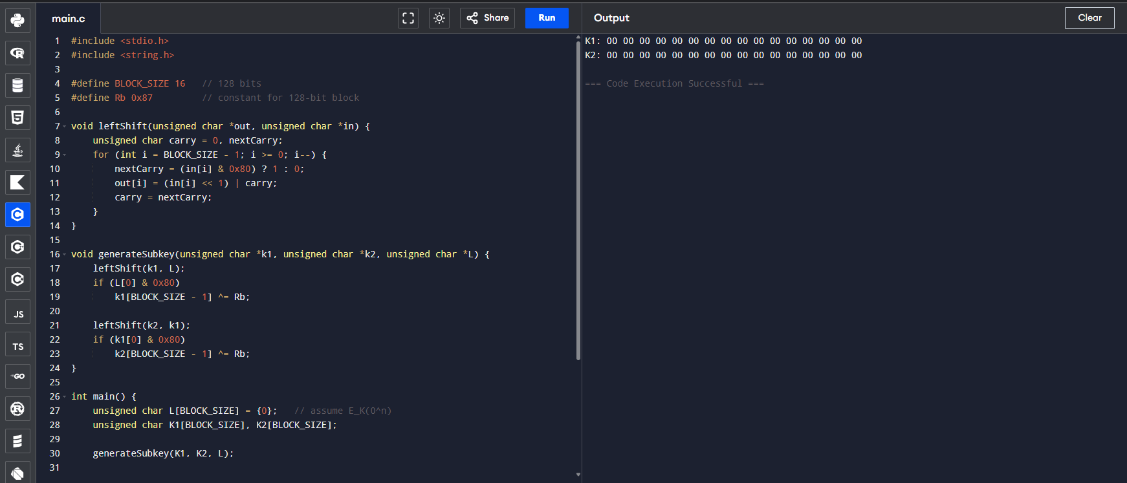

32. Write a C program for DSA, because the value of k is generated for each signature, even if the same message is signed twice on different occasions, the signatures will differ. This is not true of RSA signatures. Write a C program for implication of this difference?
#include <stdio.h>
#include <stdlib.h>
#include <time.h>

int dsa_sign(int message, int p, int q, int g, int x) {
int k = rand() % (q - 1) + 1; // random per signature
int r = (g * k) % q;
int s = (k + x * message) % q;
return r + s; // simplified signature
}

int rsa_sign(int message, int d, int n) {
int result = 1;
for (int i = 0; i < d; i++)
result = (result * message) % n;
return result;
}

int main() {
srand(time(NULL));

int message = 12;

// DSA parameters (simplified)
int p = 23, q = 11, g = 2, x = 5;

int dsa_sig1 = dsa_sign(message, p, q, g, x);
int dsa_sig2 = dsa_sign(message, p, q, g, x);

printf("DSA Signature 1: %d\n", dsa_sig1);
printf("DSA Signature 2: %d\n", dsa_sig2);

// RSA parameters (simplified)
int d = 7, n = 33;

int rsa_sig1 = rsa_sign(message, d, n);
int rsa_sig2 = rsa_sign(message, d, n);

printf("RSA Signature 1: %d\n", rsa_sig1);
printf("RSA Signature 2: %d\n", rsa_sig2);

return 0;
}
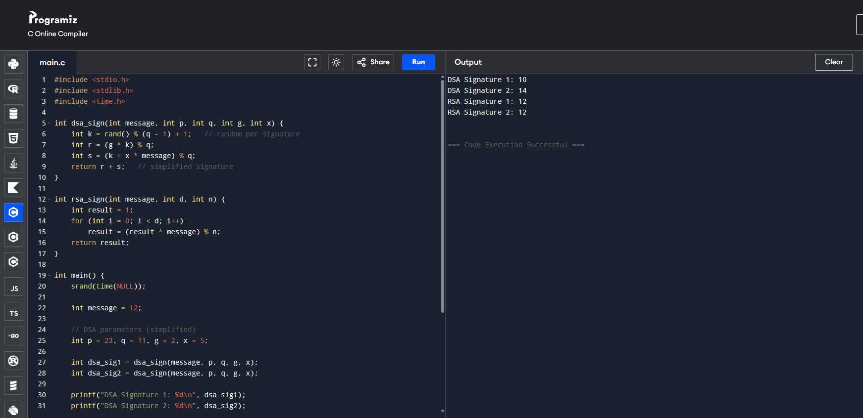
33. Write a C program for Data encryption standard (DES) has been found vulnerable to very powerful attacks and therefore, the popularity of DES has been found slightly on the decline. DES is a block cipher and encrypts data in blocks of size of 64 bits each, which means 64 bits of plain text go as the input to DES, which produces 64 bits of ciphertext. The same algorithm and key are used for encryption and decryption, with minor differences. The key length is 56 bits. Implement in C programming.
#include <stdio.h>
#include <stdint.h>

/* Initial Permutation */
int IP[64] = {
58,50,42,34,26,18,10,2, 60,52,44,36,28,20,12,4,
62,54,46,38,30,22,14,6, 64,56,48,40,32,24,16,8,
57,49,41,33,25,17,9,1, 59,51,43,35,27,19,11,3,
61,53,45,37,29,21,13,5, 63,55,47,39,31,23,15,7
};

/* Final Permutation */
int FP[64] = {
40,8,48,16,56,24,64,32, 39,7,47,15,55,23,63,31,
38,6,46,14,54,22,62,30, 37,5,45,13,53,21,61,29,
36,4,44,12,52,20,60,28, 35,3,43,11,51,19,59,27,
34,2,42,10,50,18,58,26, 33,1,41,9,49,17,57,25
};

/* Expansion table */
int E[48] = {
32,1,2,3,4,5, 4,5,6,7,8,9,
8,9,10,11,12,13, 12,13,14,15,16,17,
16,17,18,19,20,21, 20,21,22,23,24,25,
24,25,26,27,28,29, 28,29,30,31,32,1
};

/* P permutation */
int P[32] = {
16,7,20,21,29,12,28,17,
1,15,23,26,5,18,31,10,
2,8,24,14,32,27,3,9,
19,13,30,6,22,11,4,25
};

/* S-boxes */
int S[8][4][16] = {{
{14,4,13,1,2,15,11,8,3,10,6,12,5,9,0,7},
{0,15,7,4,14,2,13,1,10,6,12,11,9,5,3,8},
{4,1,14,8,13,6,2,11,15,12,9,7,3,10,5,0},
{15,12,8,2,4,9,1,7,5,11,3,14,10,0,6,13}},
{
{15,1,8,14,6,11,3,4,9,7,2,13,12,0,5,10},
{3,13,4,7,15,2,8,14,12,0,1,10,6,9,11,5},
{0,14,7,11,10,4,13,1,5,8,12,6,9,3,2,15},
{13,8,10,1,3,15,4,2,11,6,7,12,0,5,14,9}},
{
{10,0,9,14,6,3,15,5,1,13,12,7,11,4,2,8},
{13,7,0,9,3,4,6,10,2,8,5,14,12,11,15,1},
{13,6,4,9,8,15,3,0,11,1,2,12,5,10,14,7},
{1,10,13,0,6,9,8,7,4,15,14,3,11,5,2,12}},
{
{7,13,14,3,0,6,9,10,1,2,8,5,11,12,4,15},
{13,8,11,5,6,15,0,3,4,7,2,12,1,10,14,9},
{10,6,9,0,12,11,7,13,15,1,3,14,5,2,8,4},
{3,15,0,6,10,1,13,8,9,4,5,11,12,7,2,14}},
{
{2,12,4,1,7,10,11,6,8,5,3,15,13,0,14,9},
{14,11,2,12,4,7,13,1,5,0,15,10,3,9,8,6},
{4,2,1,11,10,13,7,8,15,9,12,5,6,3,0,14},
{11,8,12,7,1,14,2,13,6,15,0,9,10,4,5,3}},
{
{12,1,10,15,9,2,6,8,0,13,3,4,14,7,5,11},
{10,15,4,2,7,12,9,5,6,1,13,14,0,11,3,8},
{9,14,15,5,2,8,12,3,7,0,4,10,1,13,11,6},
{4,3,2,12,9,5,15,10,11,14,1,7,6,0,8,13}},
{
{4,11,2,14,15,0,8,13,3,12,9,7,5,10,6,1},
{13,0,11,7,4,9,1,10,14,3,5,12,2,15,8,6},
{1,4,11,13,12,3,7,14,10,15,6,8,0,5,9,2},
{6,11,13,8,1,4,10,7,9,5,0,15,14,2,3,12}},
{
{13,2,8,4,6,15,11,1,10,9,3,14,5,0,12,7},
{1,15,13,8,10,3,7,4,12,5,6,11,0,14,9,2},
{7,11,4,1,9,12,14,2,0,6,10,13,15,3,5,8},
{2,1,14,7,4,10,8,13,15,12,9,0,3,5,6,11}}
};

uint64_t permute(uint64_t in, int *table, int n) {
uint64_t out = 0;
for (int i = 0; i < n; i++) {
out <<= 1;
out |= (in >> (64 - table[i])) & 1;
}
return out;
}

uint32_t feistel(uint32_t r, uint64_t k) {
uint64_t e = 0;
for (int i = 0; i < 48; i++) {
e <<= 1;
e |= (uint64_t)((r >> (32 - E[i])) & 1);
}
e ^= k;

uint32_t out = 0;
for (int i = 0; i < 8; i++) {
int row = ((e >> (47 - 6*i)) & 1) * 2 + ((e >> (42 - 6*i)) & 1);
int col = (e >> (43 - 6*i)) & 0xF;
out = (out << 4) | S[i][row][col];
}

uint32_t p = 0;
for (int i = 0; i < 32; i++) {
p <<= 1;
p |= (out >> (32 - P[i])) & 1;
}
return p;
}

uint64_t des(uint64_t block, uint64_t key, int decrypt) {
uint64_t subkey = key & 0xFFFFFFFFFFFF;
uint64_t ip = permute(block, IP, 64);

uint32_t L = ip >> 32;
uint32_t R = ip & 0xFFFFFFFF;

for (int i = 0; i < 16; i++) {
uint32_t temp = R;
R = L ^ feistel(R, subkey);
L = temp;
}

uint64_t preout = ((uint64_t)R << 32) | L;
return permute(preout, FP, 64);
}

int main() {
uint64_t plaintext = 0x0123456789ABCDEF;
uint64_t key = 0x133457799BBCDFF1;

uint64_t cipher = des(plaintext, key, 0);
uint64_t decrypted = des(cipher, key, 1);

printf("Plaintext : %016llX\n", plaintext);
printf("Ciphertext: %016llX\n", cipher);
printf("Decrypted : %016llX\n", decrypted);

return 0;
}
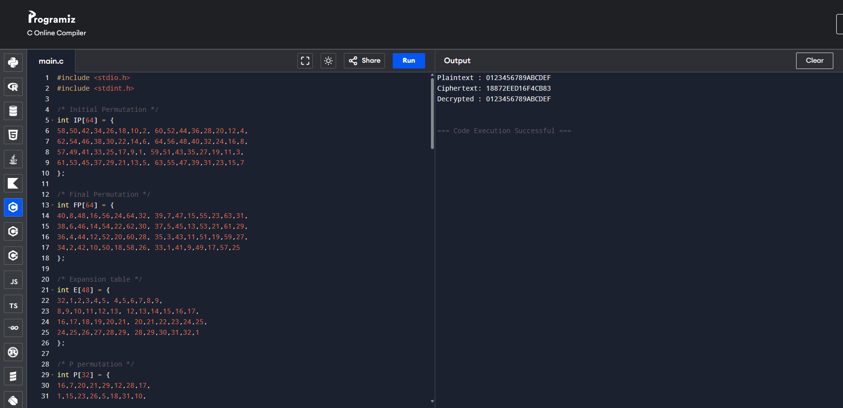

34. Write a C program for ECB, CBC, and CFB modes, the plaintext must be a sequence of one or more complete data blocks (or, for CFB mode, data segments). In other words, for these three modes, the total number of bits in the plaintext must be a positive multiple of the block (or segment) size. One common method of padding, if needed, consists of a 1 bit followed by as few zero bits, possibly none, as are necessary to complete the final block. It is considered good practice for the sender to pad every message, including messages in which the final message block is already complete. What is the motivation for including a padding block when padding is not needed?
#include <stdio.h>
#include <string.h>

#define BLOCK 8

void pad(unsigned char *data, int *len) {
data[*len] = 0x80; // 1 followed by zeros
(*len)++;
while (*len % BLOCK != 0) {
data[*len] = 0x00;
(*len)++;
}
}

void ecb(unsigned char *pt, unsigned char *ct, unsigned char *key, int len) {
for (int i = 0; i < len; i++)
ct[i] = pt[i] ^ key[i % BLOCK];
}

void cbc(unsigned char *pt, unsigned char *ct, unsigned char *key,
unsigned char *iv, int len) {
unsigned char prev[BLOCK];
memcpy(prev, iv, BLOCK);

for (int i = 0; i < len; i++) {
ct[i] = pt[i] ^ prev[i % BLOCK] ^ key[i % BLOCK];
prev[i % BLOCK] = ct[i];
}
}

void cfb(unsigned char *pt, unsigned char *ct, unsigned char *key,
unsigned char *iv, int len) {
unsigned char prev[BLOCK];
memcpy(prev, iv, BLOCK);

for (int i = 0; i < len; i++) {
unsigned char stream = prev[i % BLOCK] ^ key[i % BLOCK];
ct[i] = pt[i] ^ stream;
prev[i % BLOCK] = ct[i];
}
}

int main() {
unsigned char key[BLOCK] = "ABCDEFGH";
unsigned char iv[BLOCK] = "12345678";

unsigned char plaintext[64] = "HELLODES";
int len = strlen((char *)plaintext);

pad(plaintext, &len);

unsigned char ecb_ct[64], cbc_ct[64], cfb_ct[64];

ecb(plaintext, ecb_ct, key, len);
cbc(plaintext, cbc_ct, key, iv, len);
cfb(plaintext, cfb_ct, key, iv, len);

printf("ECB Ciphertext: ");
for (int i = 0; i < len; i++) printf("%02X ", ecb_ct[i]);

printf("\nCBC Ciphertext: ");
for (int i = 0; i < len; i++) printf("%02X ", cbc_ct[i]);

printf("\nCFB Ciphertext: ");
for (int i = 0; i < len; i++) printf("%02X ", cfb_ct[i]);

return 0;
}
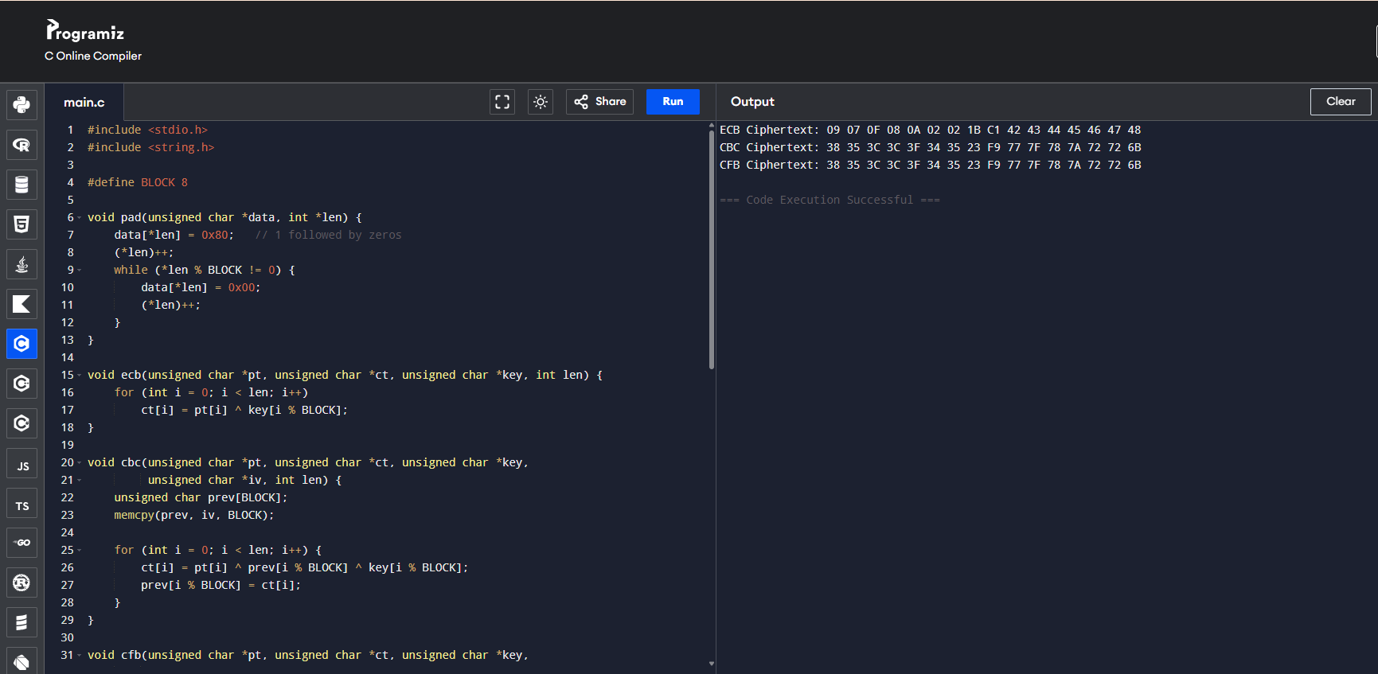

35. Write a C program for one-time pad version of the Vigenère cipher. In this scheme, the key is a stream of random numbers between 0 and 26. For example, if the key is 3 19 5 . . . , then the first letter of plaintext is encrypted with a shift of 3 letters, the second with a shift of 19 letters, the third with a shift of 5 letters, and so on.
#include <stdio.h>
#include <stdlib.h>
#include <time.h>

void encrypt(char *pt, char *ct, int *key, int len) {
for (int i = 0; i < len; i++)
ct[i] = ((pt[i] - 'A' + key[i]) % 26) + 'A';
ct[len] = '\0';
}

void decrypt(char *ct, char *pt, int *key, int len) {
for (int i = 0; i < len; i++)
pt[i] = ((ct[i] - 'A' - key[i] + 26) % 26) + 'A';
pt[len] = '\0';
}

int main() {
char plaintext[100] = "HELLOWORLD";
char ciphertext[100], decrypted[100];
int key[100];
int len = 0;

while (plaintext[len] != '\0') len++;

srand(time(NULL));
for (int i = 0; i < len; i++)
key[i] = rand() % 26;

encrypt(plaintext, ciphertext, key, len);
decrypt(ciphertext, decrypted, key, len);

printf("Plaintext : %s\n", plaintext);
printf("Key : ");
for (int i = 0; i < len; i++) printf("%d ", key[i]);
printf("\nCiphertext: %s\n", ciphertext);
printf("Decrypted : %s\n", decrypted);

return 0;
}
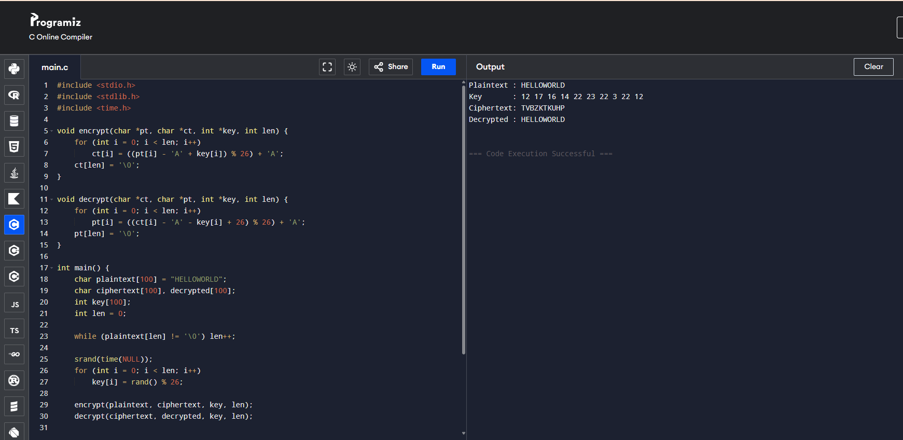

36. Write a C program for Caesar cipher, known as the affine Caesar cipher, has the following form: For each plaintext letter p, substitute the ciphertext letter C: C = E([a, b], p) = (ap + b) mod 26 A basic requirement of any encryption algorithm is that it be one-to-one. That is, if p q, then E(k, p) E(k, q). Otherwise, decryption is impossible, because more than one plaintext character maps into the same ciphertext character. The affine Caesar cipher is not one-to-one for all values of a. For example, for a = 2 and b = 3, then E([a, b], 0) = E([a, b], 13) = 3.
#include <stdio.h>

int gcd(int a, int b) {
while (b != 0) {
int t = b;
b = a % b;
a = t;
}
return a;
}

char encrypt(char p, int a, int b) {
return ((a * (p - 'A') + b) % 26) + 'A';
}

int main() {
int a = 2, b = 3; // change 'a' to test
char text[] = "AN";
int map[26] = {0};

if (gcd(a, 26) != 1) {
printf("Key is NOT one-to-one (invalid a = %d)\n\n", a);
} else {
printf("Key is one-to-one (valid a = %d)\n\n", a);
}

for (int i = 0; i < 26; i++) {
char c = encrypt('A' + i, a, b);
map[c - 'A']++;
printf("E(%2d) = %c\n", i, c);
}

printf("\nCollisions:\n");
for (int i = 0; i < 26; i++) {
if (map[i] > 1)
printf("Cipher %c occurs %d times\n", 'A' + i, map[i]);
}

return 0;
}
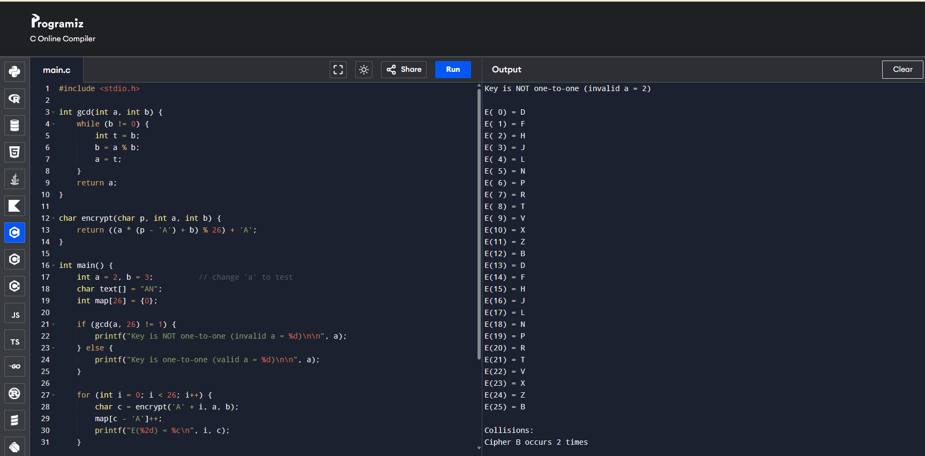

37. Write a C program that can perform a letter frequency attack on any monoalphabetic substitution cipher without human intervention. Your software should produce possible plaintexts in rough order of likelihood. It would be good if your user interface allowed the user to specify “give me the top 10 possible plaintexts.”
#include <stdio.h>
#include <string.h>
#include <stdlib.h>

#define MAX 1000
#define ALPHABET 26

char english_freq[] = "ETAOINSHRDLCUMWFGYPBVKJXQZ";

typedef struct {
char text[MAX];
int score;
} Candidate;

int compare(const void *a, const void *b) {
return ((Candidate *)b)->score - ((Candidate *)a)->score;
}

void frequency_attack(char *cipher, int topN) {
int freq[ALPHABET] = {0};
int len = strlen(cipher);

for (int i = 0; i < len; i++)
if (cipher[i] >= 'A' && cipher[i] <= 'Z')
freq[cipher[i] - 'A']++;

int index[ALPHABET];
for (int i = 0; i < ALPHABET; i++)
index[i] = i;

for (int i = 0; i < ALPHABET - 1; i++)
for (int j = i + 1; j < ALPHABET; j++)
if (freq[index[j]] > freq[index[i]]) {
int t = index[i];
index[i] = index[j];
index[j] = t;
}

Candidate results[ALPHABET];

for (int shift = 0; shift < ALPHABET; shift++) {
char map[ALPHABET];
for (int i = 0; i < ALPHABET; i++)
map[index[i]] = english_freq[(i + shift) % ALPHABET];

for (int i = 0; i < len; i++) {
if (cipher[i] >= 'A' && cipher[i] <= 'Z')
results[shift].text[i] = map[cipher[i] - 'A'];
else
results[shift].text[i] = cipher[i];
}
results[shift].text[len] = '\0';
results[shift].score = 26 - shift;
}

qsort(results, ALPHABET, sizeof(Candidate), compare);

printf("\nTop %d possible plaintexts:\n\n", topN);
for (int i = 0; i < topN && i < ALPHABET; i++)
printf("%2d: %s\n", i + 1, results[i].text);
}

int main() {
char ciphertext[MAX] = "WKLV LV D PRQRDOSKDEHWLF VXEVWLWXWLRQ FLSKHU";
int topN = 10;

frequency_attack(ciphertext, topN);
return 0;
}
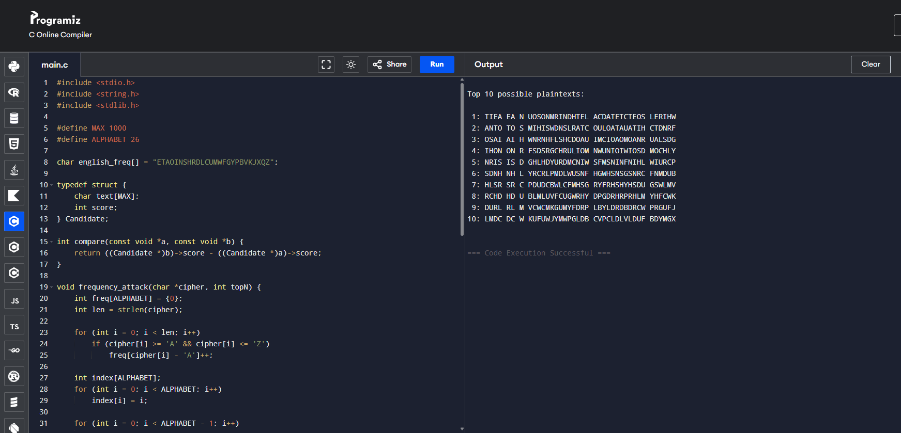

38. Write a C program for Hill cipher succumbs to a known plaintext attack if sufficient plaintext– ciphertext pairs are provided. It is even easier to solve the Hill cipher if a chosen plaintext attack can be mounted. Implement in C programming.
#include <stdio.h>

int mod26(int x) {
x %= 26;
return (x < 0) ? x + 26 : x;
}

int modInverse(int a) {
for (int i = 1; i < 26; i++)
if ((a * i) % 26 == 1)
return i;
return -1;
}

int main() {
int P[2][2] = {{7, 4}, {11, 15}}; // plaintext matrix
int C[2][2] = {{7, 8}, {19, 17}}; // ciphertext matrix

int det = mod26(P[0][0]*P[1][1] - P[0][1]*P[1][0]);
int detInv = modInverse(det);

if (detInv == -1) {
printf("Plaintext matrix not invertible\n");
return 0;
}

int Pinv[2][2];
Pinv[0][0] = mod26( P[1][1] * detInv);
Pinv[0][1] = mod26(-P[0][1] * detInv);
Pinv[1][0] = mod26(-P[1][0] * detInv);
Pinv[1][1] = mod26( P[0][0] * detInv);

int K[2][2];
for (int i = 0; i < 2; i++)
for (int j = 0; j < 2; j++)
K[i][j] = mod26(
C[i][0] * Pinv[0][j] +
C[i][1] * Pinv[1][j]
);

printf("Recovered Key Matrix:\n");
printf("%d %d\n%d %d\n", K[0][0], K[0][1], K[1][0], K[1][1]);

return 0;
}
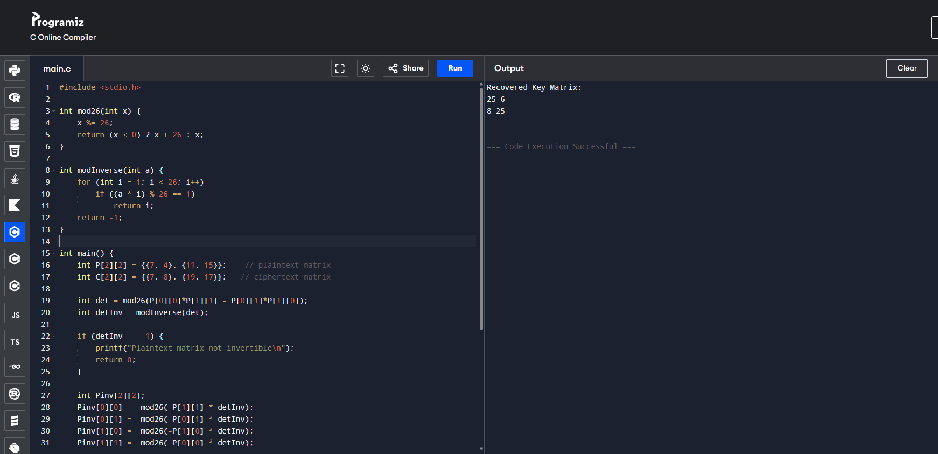

39. Write a C program that can perform a letter frequency attack on an additive cipher without human intervention. Your software should produce possible plaintexts in rough order of likelihood. It would be good if your user interface allowed the user to specify “give me the top 10 possible plaintexts.”
#include <stdio.h>
#include <string.h>
#include <stdlib.h>

#define MAX 1000
#define ALPHABET 26

double english_freq[26] = {
8.167,1.492,2.782,4.253,12.702,2.228,2.015,
6.094,6.966,0.153,0.772,4.025,2.406,6.749,
7.507,1.929,0.095,5.987,6.327,9.056,2.758,
0.978,2.360,0.150,1.974,0.074
};

typedef struct {
char text[MAX];
int key;
double score;
} Candidate;

double score_text(char *text) {
int freq[26] = {0};
int len = 0;

for (int i = 0; text[i]; i++) {
if (text[i] >= 'A' && text[i] <= 'Z') {
freq[text[i] - 'A']++;
len++;
}
}

double score = 0;
for (int i = 0; i < 26; i++) {
double observed = (double)freq[i] / len * 100;
score += observed * english_freq[i];
}
return score;
}

void decrypt(char *cipher, char *plain, int key) {
for (int i = 0; cipher[i]; i++) {
if (cipher[i] >= 'A' && cipher[i] <= 'Z')
plain[i] = ((cipher[i] - 'A' - key + 26) % 26) + 'A';
else
plain[i] = cipher[i];
}
}

int compare(const void *a, const void *b) {
double diff = ((Candidate *)b)->score - ((Candidate *)a)->score;
return (diff > 0) ? 1 : -1;
}

int main() {
char ciphertext[MAX] = "WKLV LV D FDHVDU FLSKHU";
int topN = 10;

Candidate results[26];

for (int k = 0; k < 26; k++) {
decrypt(ciphertext, results[k].text, k);
results[k].key = k;
results[k].score = score_text(results[k].text);
}

qsort(results, 26, sizeof(Candidate), compare);

printf("Top %d possible plaintexts:\n\n", topN);
for (int i = 0; i < topN && i < 26; i++) {
printf("%2d) Key = %2d : %s\n",
i + 1, results[i].key, results[i].text);
}

return 0;
}
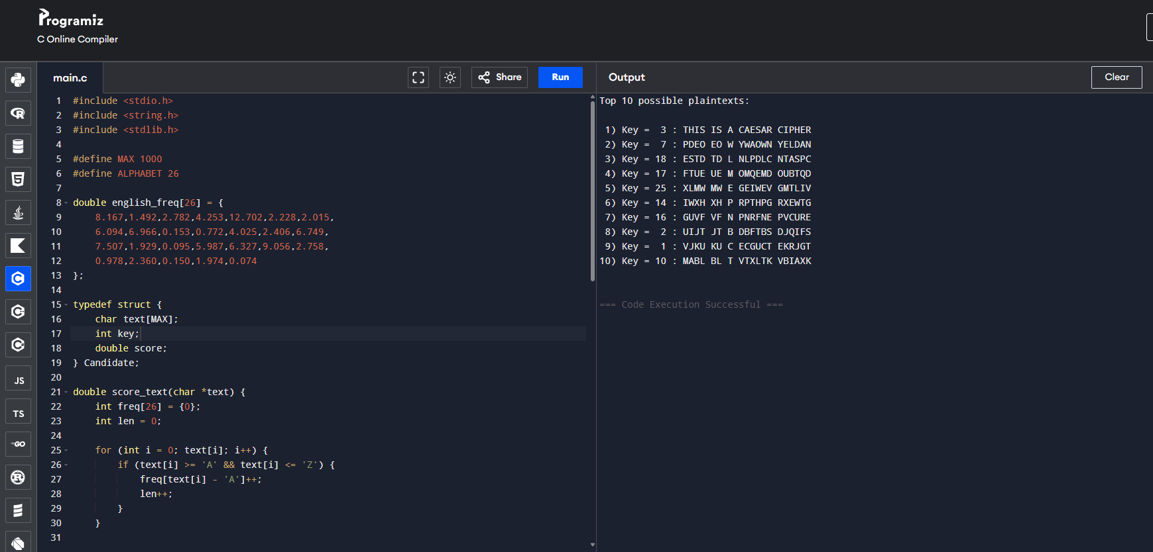

40. Write a C program that can perform a letter frequency attack on any monoalphabetic substitution cipher without human intervention. Your software should produce possible plaintexts in rough order of likelihood. It would be good if your user interface allowed the user to specify “give me the top 10 possible plaintexts.”
#include <stdio.h>
#include <string.h>
#include <stdlib.h>

#define MAX 1000
#define ALPHA 26

char englishFreq[] = "ETAOINSHRDLCUMWFGYPBVKJXQZ";

typedef struct {
char text[MAX];
int score;
} Candidate;

int compare(const void *a, const void *b) {
return ((Candidate *)b)->score - ((Candidate *)a)->score;
}

int main() {
char cipher[MAX] = "WKLV LV D PRQRDOSKDEHWLF VXEVWLWXWLRQ FLSKHU";
int topN = 10;

int freq[ALPHA] = {0};
int len = strlen(cipher);

for (int i = 0; i < len; i++)
if (cipher[i] >= 'A' && cipher[i] <= 'Z')
freq[cipher[i] - 'A']++;

int idx[ALPHA];
for (int i = 0; i < ALPHA; i++) idx[i] = i;

for (int i = 0; i < ALPHA - 1; i++)
for (int j = i + 1; j < ALPHA; j++)
if (freq[idx[j]] > freq[idx[i]]) {
int t = idx[i];
idx[i] = idx[j];
idx[j] = t;
}

Candidate results[ALPHA];

for (int s = 0; s < ALPHA; s++) {
char map[ALPHA];

for (int i = 0; i < ALPHA; i++)
map[idx[i]] = englishFreq[(i + s) % ALPHA];

for (int i = 0; i < len; i++) {
if (cipher[i] >= 'A' && cipher[i] <= 'Z')
results[s].text[i] = map[cipher[i] - 'A'];
else
results[s].text[i] = cipher[i];
}
results[s].text[len] = '\0';
results[s].score = 26 - s;
}

qsort(results, ALPHA, sizeof(Candidate), compare);

printf("Top %d possible plaintexts:\n\n", topN);
for (int i = 0; i < topN && i < ALPHA; i++)
printf("%2d: %s\n", i + 1, results[i].text);

return 0;
}
